You will need an IDE and a g++ compiler for C/C++ coding

1. Install Atom
   * <https://atom.io/>
2. Install gpp-compiler package for Atom
   * <https://atom.io/packages/gpp-compiler>
3. Install MinGW
   * <https://osdn.net/projects/mingw/releases/>
   * Select **mingw-get-setup.exe** (Should have a blue icon next to the text to click on)
   * Install MinGW under C:\MinGW
   * Install mingw32-gcc-g++-bin

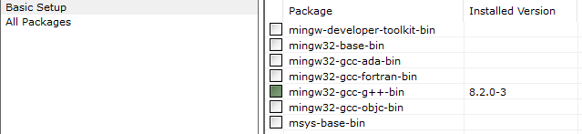

1. Set the environment variables for the PATH of mingw
   * Guide: <https://www.rose-hulman.edu/class/csse/resources/MinGW/installation.htm>

You should now be able to run Atom and compile a .ccp file using F5